**In the introduction,** solution to the algebraic and transcendental equations, let us enlighten the type of equations, we have algebraic and transcendental equations.

In the simple words, the equation of the type of “f(x)=0” is algebraic and if and only if it contains any power of x, then the equation is polynomial. The equation is transcendental, if it contains powers of x, exponential functions, logarithms functions, trigonometric functions, etc.

Algebraic equation example: “2x = 5 , x2 +x =2, x7+=x(1+2x)”.

Transcendental equation example: “x+sinx=0 , e√x = x, tanx+=x”.

# INTERMEDIATE VALUE THEOREM

Intermediate value theorem explains that if ‘f’ is a function on [a,b] and the sign of ‘f(a)’ is different from the sign of ‘f(b)’, that is “f(a)f(b)<0”, then there exists a point c, in the interval (a,b) such that f(c) = 0. Hence, any value “c ∈ (a,b) (c belongs to [a,b] ) ” can be taken as an initial approximation to the root.

# BISCTION METHOD

Bisection method is the simplest method. This method is also known as *binary chopping method or half-interval method*. Bisection relies on the fact that if “f(x)” is real or continuous in the interval “a<x<b” and “f(a)” and “f(b)” are of opposite signs, that is “f(a)f(b)<0”, then there is at least one real root in the interval between ‘a’ and ‘b’ (there may be more the one root in the interval).

Let “x1 = a” and “x2 = b”, let us set another point x0 to be the midpoint between ‘a’ and ‘b’, please see the formula below:

Then, there will be three possible conditions, please follow the algorithms below:

### ALGORITHM – BISECTION METHOD

1. Decide initial values for “x1” and “x2” and stopping criterion E. Initial values should satisfy *intermediate value theorem.*
2. Compute “f(x1)” and “f(x2)”.
3. If “f(x1)f(x2)>0” and “x1” and “x2” do not give any root then go to step 7 otherwise go to step 4.
4. Compute x0 = (x1+x2)/2 and calculate f(x0)
5. If “f(x1)f(x2)<0”   
    then set x2 = x0otherwise   
    set x1 = x0
6. If absolute value of (x1+x2)/ x2 is less than error E then  
    root = (x1 + x2)/2,  
    use the value of root  
    go to step 7  
   else  
    go to step 4
7. Stop

To find stopping criterion (E) set any value between 0 and 1. Please notice the smaller you choose, the better you get.

# REGULA FALSI METHOD

In the previous method, the interval between x1 and x2 is the equal half, without knowing the location of the root, it may be possible that the root is closer to one end than the other (Please see the graph below).

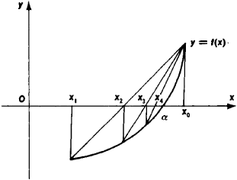

Please note that solution or root is closer x1. Let us join the points x1 and x2 by a straight line. The point of intersection of this line with the x-axis (xo) gives an improved estimate of the root and is called false position of the root.

We determine by intermediate value theorem , whether the root lies in (x,x0) or (xo,x2) we repeat the process if xo,x1,x2,x3 ……… xn are the sequence of approximation , then we stop the iteration when following condition satisfy

### ALGORITHM –REGULA FALSI METHOD

1. Decide initial values for “x1” and “x2” and stopping criterion E. Initial values should satisfy *intermediate value theorem.*
2. Compute “f(x1)” and “f(x2)”.
3. If “f(x1)f(x2)>0” and “x1” and “x2” do not give any root then go to step 7 otherwise go to step 4.
4. Compute x0  by using *regula falsi method* calculate f(x0)
5. If “f(x1)f(x2)<0”   
    then set x2 = x0otherwise   
    set x1 = x0
6. If absolute value of (x1+x2)/ x2 is less than error E then  
    go to step 7  
   else  
    go to step 4
7. Stop

# NEWTON-RAPHSON METHOD

Assume, “x1” is an approximate root of “f(x)=0”. Draw a tangent at curve “f(x)” at “x=x1” as shown below in the graph.

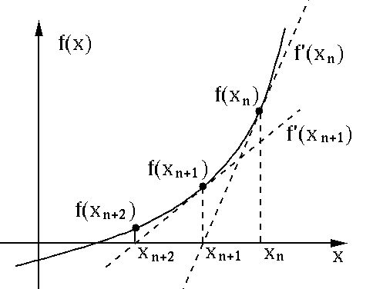

The point of intersection of this tangent with the x-axis gives the second approximation to the root. In other words, “f” is differentiable function in some interval [a, b] containing the root.

The slope of tangent or differentiation is simplified, please refer below formula:

Where “f(x)” is the slope of “f(x)” at “x=x1”. To get x2(xn+1), we follow the *newton-raphson method*. Please see the formula below:

Then next approximation would be

Then next approximation will be similar to above and so on.

With the reference of above formula, we generalised the formula, please refer below:

Note: please try to derive *newton-raphson method* using *Taylor series* for practice.

### ALGORITHM –NEWTON-RAPHSON METHOD

1. Assign an initial value to x1, say x0
2. Evaluate f(x0) and f’(x0)
3. Find the improved estimate of x0
4. Check for accuracy of the latest estimate.  
   Compare relative error to a predefined value E.  
   if , stop otherwise go to step 5
5. Replace x0 by x1 and repeat steps 3 and 4.